Project Design Phase-II
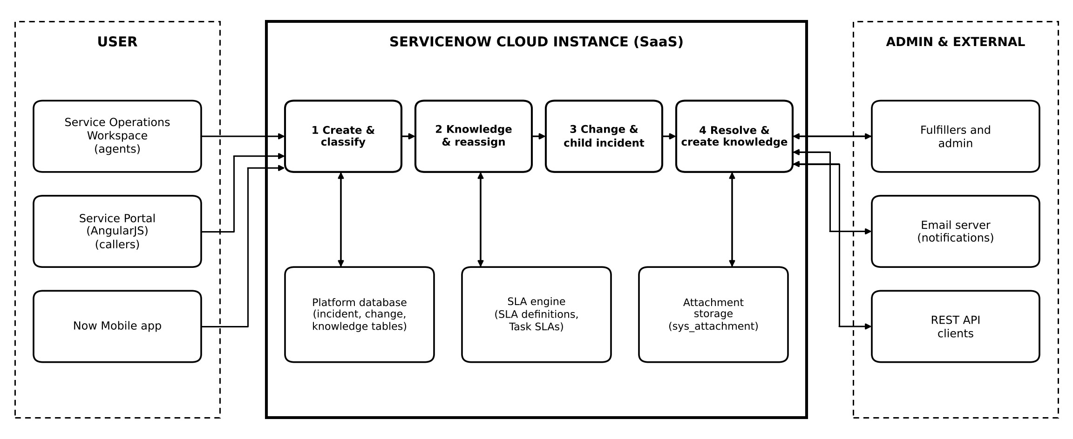
Technology Stack (Architecture & Stack)
Date | 24 October 2026
Team ID
Project Name | Incident Lifecycle Automation in ServiceNow
Maximum Marks | 4 Marks

Technical Architecture
Every incident moves through four stages on one ServiceNow cloud instance: create and classify, knowledge and reassignment, change and child incident, and resolution with knowledge creation.

Table-1: Components & Technologies
S.No | Component | Description | Technology
1 | User Interface | Service Operations Workspace for agents and technicians to create, classify and work incidents. Web portal and mobile app for callers. | Service Operations Workspace, Service Portal (HTML, CSS, JavaScript, AngularJS), Now Mobile app
2 | Application Logic-1 | Incident creation and classification: form fields, category and subcategory, urgency, service, service offering and configuration item. | Incident module, UI Policies, Client Scripts, Business Rules
3 | Application Logic-2 | Knowledge integration: Agent Assist suggests articles, which are marked helpful and attached. Knowledge article creation from the resolved incident. | Agent Assist, Knowledge Management (IT knowledge base, Standard template)
4 | Application Logic-3 | Reassignment and escalation: assignment groups (Service  Desk, Network), Watch list, Work notes list and On Hold state. | Assignment Groups, Roles, Watch list, Notifications
5 | Application Logic-4 | Change and related incidents: emergency change request from the incident, child incidents and related lists. | Change Management, Parent-Child Incidents, Related Lists
6 | Application Logic-5 | SLA tracking: Task SLAs visible in Related Records of the incident. | SLA Definitions, Task SLAs
7 | Database | Incident, change, knowledge and SLA data in relational tables (the incident table extends task). | ServiceNow platform relational database
8 | Cloud Database | Database service hosted on the cloud instance. | ServiceNow cloud instance database (Personal Developer Instance)
9 | File Storage | Attachments on incident records. | ServiceNow attachment storage (sys_attachment)
10 | Configuration Data | Services, service offerings and configuration items used to classify incidents. | CMDB (cmdb_ci_service, service_offering)
11 | External API-1 | Email notifications to watchers and callers. | Notifications, Inbound Email Actions, SMTP/IMAP
12 | External API-2 | Optional integration of third-party systems with incident data. | REST API / REST Message (JSON)
S.No | Component | Description | Technology
13 | Machine Learning Model | Not used in this project. Predictive Intelligence and Virtual Agent are possible later extensions. | Not used
14 | Infrastructure (Server /  Cloud) | Application deployment on the cloud. Local server configuration: not required. Cloud server configuration:  ServiceNow-hosted instance. | ServiceNow cloud instance (SaaS)

Table-2: Application Characteristics
S.No | Characteristics | Description | Technology
1 | Open-Source Frameworks | Open-source front-end frameworks used in the portal. | AngularJS, Bootstrap, jQuery
2 | Security Implementations | Access control, authentication, user impersonation for role testing, encryption and auditing. | ACLs, roles and groups, HTTPS/TLS, SSO (SAML) and MFA, audit and history logs
3 | Scalable Architecture | Three-tier cloud architecture: presentation, application and database. | ServiceNow multi-tier cloud architecture
4 | Availability | Data-center replication, failover and managed backups. | ServiceNow cloud infrastructure
5 | Performance | Indexing, caching, scheduled jobs and asynchronous business rules. | DB indexing, platform caching, scheduled jobs, async business rules

